Ex:9 AI and Analytics using Zia

Title: Mystery Detective AI – Intelligent Case Investigation System

Aim: To design and develop an AI-powered investigation application using Zoho Creator integrated with Zia, capable of analyzing incident reports, organizing evidence, reconstructing timelines, identifying inconsistencies, generating investigation hypotheses, and producing professional investigation reports to assist users in solving mystery or security-related cases.

Theory:
Mystery Detective AI is an intelligent case analysis system that leverages the capabilities of Zoho Creator and Zia Artificial Intelligence to support investigative workflows. Traditional investigations require manual analysis of witness statements, evidence, timelines, and reports. This process is often time-consuming and susceptible to human error. Mystery Detective AI automates these tasks by analyzing structured and unstructured information submitted by users.
The application allows investigators to enter incident details, upload evidence, and provide witness statements. Zia processes the information using Natural Language Processing (NLP) to:
- Summarize the case
- Extract verified facts
- Identify missing information
- Build a chronological timeline
- Detect contradictions
- Analyze available evidence
- Generate multiple investigation hypotheses
- Recommend the next investigative actions
- Produce a professional investigation report
The application improves investigation efficiency while ensuring that conclusions are based only on available evidence and logical reasoning rather than assumptions.
Procedure:

Step 1: Open the Mystery Detective AI application developed in Zoho Creator.

Step 2: Create a new investigation case.

Step 3: Enter the following information:
- Case Title
- Incident Description
- Date and Time
- Location
- Witness Statements
- People Involved
- Additional Notes

Step 4: Upload available evidence such as:
- Images
- Documents
- PDFs
- Videos (optional)

Step 5: Submit the investigation request.

Step 6: Zia analyzes the case information and performs:
- Case summarization
- Fact extraction
- Timeline reconstruction
- Evidence categorization
- Contradiction detection
- Hypothesis generation
- Risk assessment

Step 7: Review the generated investigation report.

Step 8: Export or save the report for future reference.

Screenshots:

Home Dashboard
- Display the application's main dashboard with navigation menu.
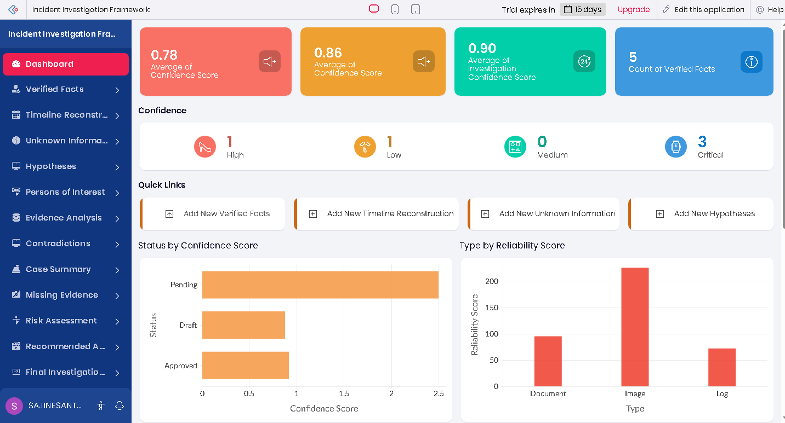

Contradictions Report
- Display the case entry form with fields for incident details.
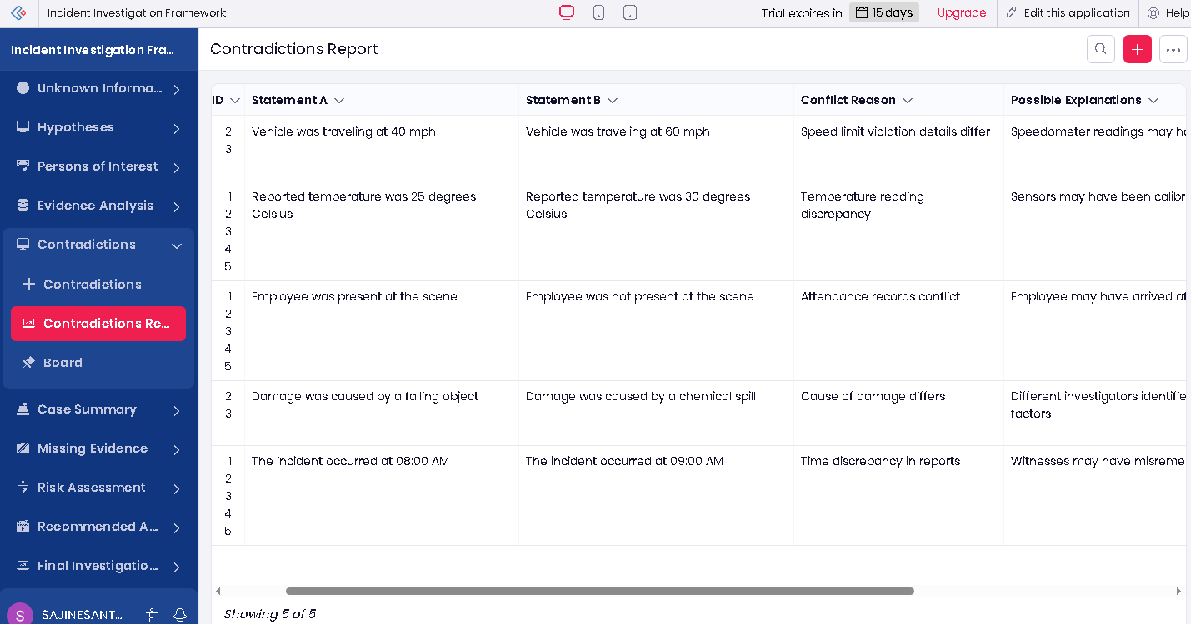
Evidence Upload Page
- Show the interface used to upload images, documents, or other evidence.
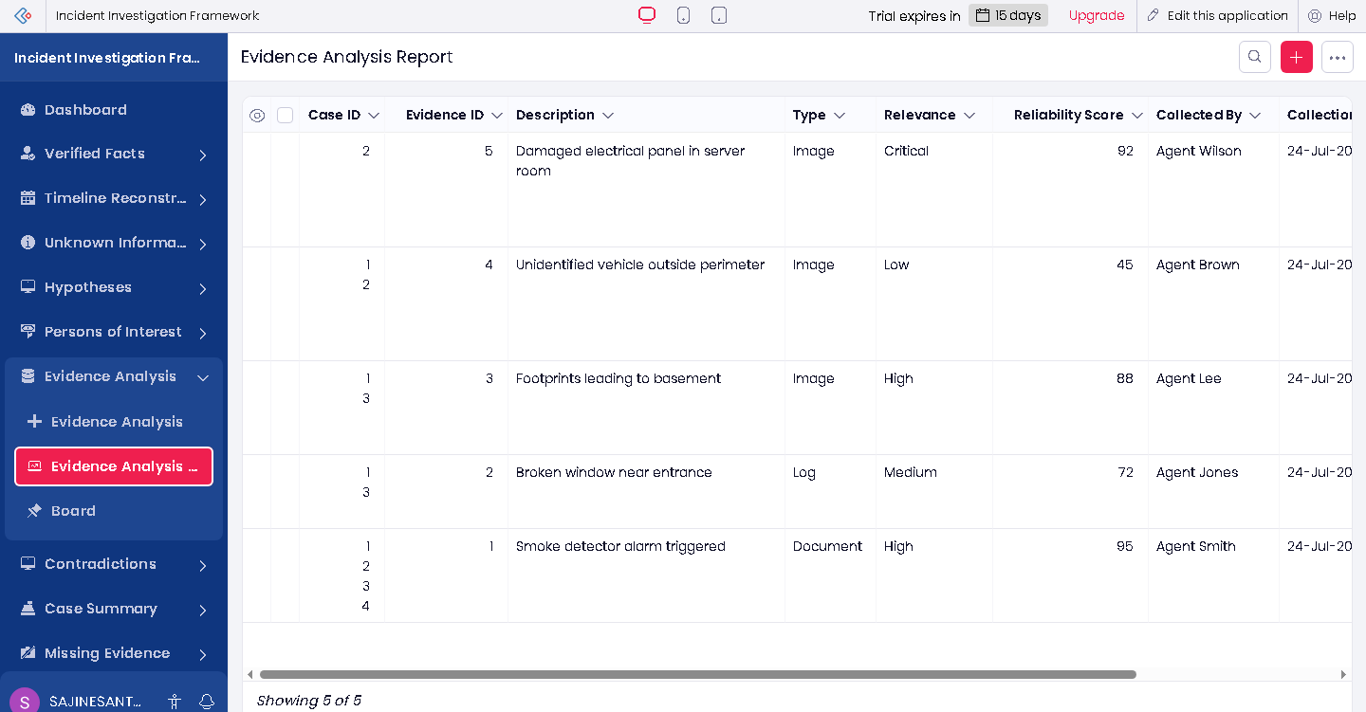

Evidence Report
- Display the final generated evidence report.
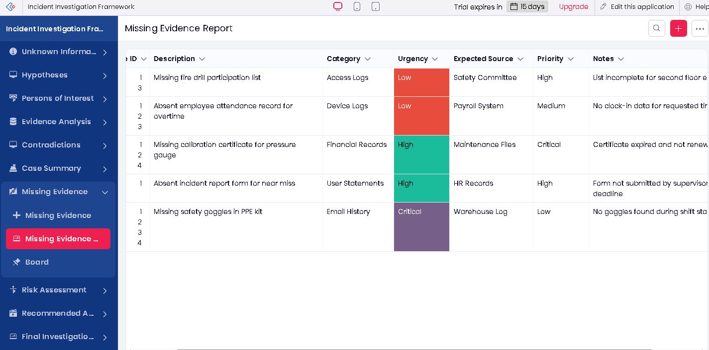

Verified Facts Report
- Show the list of previous Verified facts.
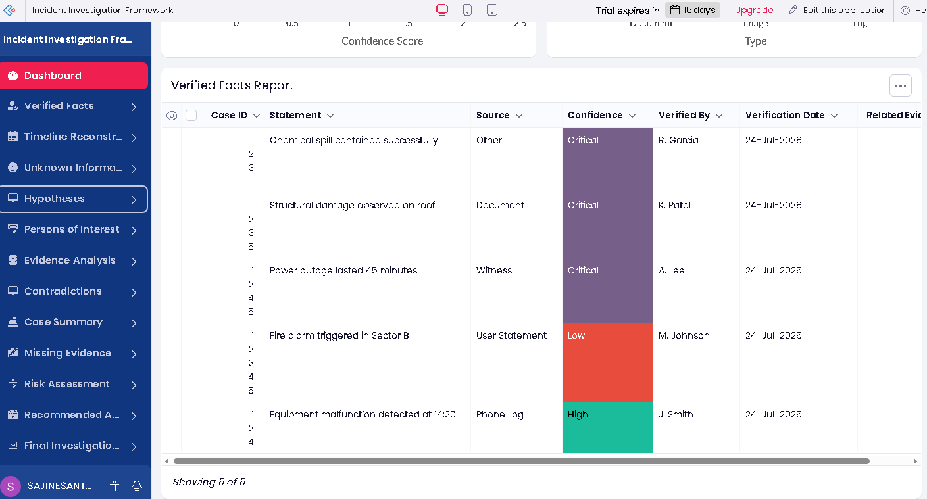

Result:
The Mystery Detective AI application was successfully developed using Zoho Creator with Zia AI integration.

